International Counseling & Consulting, Inc.

Depression Assessment Questionnaire

Depression is complex and relates to many subtle variables in its causes and effects. Much of what we call depression represents distorted and impaired thoughts, feelings, and behaviors, though the origination and cause of depression is unique to each individual’s experience. However, depression is not automatically or always bad, wrong, sinful, or even abnormal. It clearly is a symptom, though, of the human condition.

[The following comments reflect my personal perspective from a Christ-centered point of view. Please know that if you do not personally believe in Jesus, or pursue a religious faith different than following Jesus Christ, the information asked for on the following pages will still be significantly helpful in accurately assessing, diagnosing, and treating your particular struggle. In addition, your values and beliefs will be respected and included in our collaborative effort to address those struggles.]

For me, a comprehensive understanding of depression begins with Adam in the Old Testament book of Genesis and the ‘warfare theodicy’ that has at its core a titanic contest between God and Satan. Though depression is not a condition necessarily inflicted by the Lord, it may not inevitably be eradicated or prevented by simply being in Christ. In fact, biblical characters from Cain to Elijah to Job to Amnon to David to Jeremiah to Jonah to Paul (and others)—and yes, it seems, even Jesus—experienced mental and emotional anguish, and sometimes depression. Whatever the reason, the reality that we live in a mental/emotional war zone outside the Garden of Eden seems inescapable. Maybe the picture of Jesus in Isaiah 53 as the Suffering Servant is appropriate as we begin to explore your own personal pain:

“He was despised”

“Rejected by men”
“A man of sorrows”
“Familiar with suffering”
“He took up our infirmities”
“And carried our sorrows”
“And by his wounds we are healed”

It is my hope that this process will help you address your current emotional, mental, and physical reality in such a way so as to not simply “feel better,” and to be less depressed, but that you would become more like Jesus Christ and experience the redemptive healing of His love in your brain, mind, will, and emotions.

The following questions are designed to assess for clinical depression symptoms. (The items will also help delineate different types of depression, some anxiety features, and some physiological/medical events and conditions.) Please give as much detail as you can. Ideally, if possible, please have your spouse (or a friend) also fill this form out on you. The insights from another can often add to the overall understanding of what you are experiencing. (Have them fill out a separate form altogether or add their comments in a different color of ink, etc.) Please don’t overlook the Disturbing Life Experiences Assessment and the Beck Depression Inventory at the end of this document.

Thank you for looking carefully at this questionnaire. Your responses will be taken seriously and respected confidentially. With God’s help this information will hopefully be used to increase the reality, the capacity, and the impact of God’s love in your life as central to the healing process.

Remember that THERAPEUO, one of the Greek words for healing, has three components:

- to sincerely care for another,
- to perform practical acts of service for another,
- and to help relieve the symptoms of another.

It is my desire that you will experience the Lord working against the work of the Enemy, that you will experience God’s healing in your life, and that our interaction can aid in this process. Psalm 25:15.

Geoffrey Paetzhold, DPhil, LPC

PERSONAL & CONFIDENTIAL

Name: _____________________________________ Date of Birth: ____________________

Address:____________________________________________________________________

City: _______________________ State: _______________ Zip: _________ - ___________

Contact Info. Phone: H- (____)-_____- _______; C- (____)- _____- _______;

Email: ____________________________________

Today’s Date: (mm/dd/yyyy) _____/____/________

*GENERAL INSTRUCTIONS: Please give brief but informative answers to the following questions and/or comments. Many questions can simply be answered “Yes” or “No”. (Please feel free to use “N” for No and “Y” for Yes.) Please explain to the side or on the back any further details that would help increase understanding of your situation. THANK YOU for taking the time to complete this form!

**CAUTION: Please realize that by answering a particular question, or through simply filling out this questionnaire in general, you may experience emotional turmoil or pain. If you find it too difficult to complete, please stop, or just skip too-painful-to-answer items. That is OK. My desire is that this information-gathering process be as safe as possible. Thanks again for taking the time and energy to provide the information below.

***If English is NOT your first language, please write down the following language information. Thanks.

First Language: ________________________
Years speaking English: _________________

Also, if there are words or descriptions of an illness, a medicine, a condition, or an experience, etc., that you cannot recall the English word for, please write your answer down in your own language and circle it. I will still be able to find out what that means and will better understand your situation at the same time. Thanks.

There may be terms and phrases unfamiliar to you in English. If so, put the ltters “IDK” in answer to that question. IDK = “I Don’t Know” and tells me you are simply not familiar with that particular word, term, or phrase. Thanks.
_____________________________________
NOTE: If possible, please make a copy of your completed questionnaire before sending me the original.

PHYSICAL: Information and Symptoms

Height: _____________ Weight: ______________ Date of last complete physical: ___________________________

Current: MD and/or Primary Care Physician (PCP): ________________________________________________________________________

Current Medications: Include Name of drug, dose amounts, starting date of: [Note: please include birth control medications and OTC supplements.]
Drug Name Dose Amount Starting Date
___________________________________________________________________________________________________________________________________________________________________________________________________________________________________________________________________________________________________________________________________________________________________________________________________________________________________________________________________________________________________________________________________________________________________________________________________________________

Previous Psychiatric Medications: me, dose amount, starting date, and duration for any

Drug Name Dose Amount Start Date End Date
_________________________________________________________________________________________________________________________________________________________________________________________________________________________________________________________________________________________________________________________________________________________________________________________________________________________________________________________________________________________________________________________________________________________________________________________________________________________________________________________________________________________________________________________________________________________________________________________________________________________________________________________

Previous surgeries: (including childhood): Approximately when? What was the procedure?

Date Procedure
__________________________________________________________________________________________________________________________________________________________________________________________________________________________________________________________________________________________________________________________________________________________________________________________________________________________________________________________________

1. Appetite changes: increased? ______ diminished? ______ none ______

2. Dietary changes: ______ (e.g., particular food cravings; abrupt, increased consumption of sweets, carbohydrates, etc.?)

- Weight loss, gain, or fluctuations of 5 – 7 pounds or more in past 6 months? ______

Loss? _____ Gain? _____ How much? _____

Fluctuations during the past 12 months? _____ Range: High _____ Low _____

5. Sleep
- Trouble going to sleep? ______ (On average, after laying down, how long before sleep occurs? ______ minutes)
- Trouble staying asleep? ______
- Early morning awakening with inability to return to sleep? ______ (I awaken at approximately ______ A.M. each morning. It takes __________ minutes or _____ hours before returning to bed.)
- Excessive sleeping/resting during the day? _____ (Hours per day? _____)
- Excessive leg and/or arm movements during sleep? _________
- History for prolonged and loud snoring? ________ Family members diagnosed with sleep apnea? _______ Who? _________________________________
- Personal history for snoring? _____ sleep apnea? _____; hypopnea? _____; narcolepsy? _____
- Non-restorative sleep regardless of amount of time sleeping/resting? _____
- Disturbing dreams/nightmares? _____ (Number per week: _____ per month: _____) (Repeated themes or scenes? ______) If yes, briefly describe below:

- Do you have anxiety during the day or in the evening about having a nightmare interrupt your sleep? _____ (and/or) Do you have anxiety about the content of the nightmare being disturbing during the day? _____
- As a child, did you experience night terrors? _____ (Age of onset? _______) (How long did these occur? (_____ months / years )
- Inverted sleep patterns? (i.e., awake at night and excessive tiredness/sleepiness during the day not attributable to 3rd shift work schedules, jet lag, etc.?) _____
- Number of overseas trips you have made in the past 18 months? _____
- Periods of time when sleep was reduced to little or none for 2–5 days without impaired daily functioning? _____
- Long-term ability to function well on 5 or less hours of sleep per night? _____
Mood, Affect, and Energy
6. Marked changes in mood from morning to evening? (For example: down to up? _____; up to down? _____; cycles during day? _____)

- Regular daily fatigue? _____ (Tire easily: condition not related to an identifiable illness?) _____

- Significantly reduced sexual energy ____;desire ____; activity ____?

- Significantly increased sexual energy ____; desire ____; activity ____?

- Tearfulness? _____ (Easily induced ____; often ____; intense ____; and/or prolonged ____?)

- Slower physical movements? _____ (If yes, when and how noticed?)

- Speech:
a. Weaker, lower voice intonations?____ Slower? _____ Garbled at times? _____

b. Stronger, louder intonations? _____ Rapid? _____ Pressured? _____

- Chronic headaches _____; back pain _____; or nausea _____ (not directly attributable to a past or present identifiable physical injury or illness)

- Joint and/or muscle aches not due to physical exertion or exercise? _____

- Previous history for fainting and loss of consciousness? _____ Have you ever taken a “tilt test” _____ ; or been provisionally diagnosed with dysautonomia _____?

Interpersonal and Social Dynamics

- Excessive attachment to staying in one’s home, compound, or flat? ______

- Difficult (if not almost impossible) to control irritability/anger _____ and/or mistrust _____due to minimal provocation? _____

  - Physical violence towards things? _____ others? _____ self? _____

  - If towards self, please try to explain how you hurt yourself, and, in general, what part of your body you use to usually hurt yourself. Thanks. (See # 37.)

- Strong, chronic desires to withdraw from people; avoid social situations? _____

- Strong anxiety, almost panic, when alone or not in the presence of others? _____

- Strong anxiety/fear if specific individuals are absent, not available, or leave? _____

- Strong to almost overwhelming sense of inferiority and negative comparison when in presence of others? _____; or when thinking of others? _____

- Excessively shy? _____ Since childhood? _____ Only recently? _____

- Tendency to avoid conflict, to be passive, non-confrontational, and non-assertive? _____

- Strong inhibition regarding expressing thoughts and feelings in most social contexts? _____

Cognitive and Mental Processing [Simply answering ‘yes’ to some of the questions below may be disturbing to you. If you experience strong emotions that feel overwhelming, please mark question # 46 and we will discuss this section together in the office.]

- Marked inability to concentrate? _____

- Easily distracted? _____?

- Short-term memory difficulties? _____ (e.g., remembering names of people _____; names of familiar objects _____; where items were placed _____; what you recently read _____; etc.?)

- Inability to sustain follow-through of plans, activities, and commitments? _____

- Gradual, growing disinterest in engaging with friends and/or routine social connections? _____

- Lowered concern for and/or attention to hygiene, appearance, etc.? _____

- Loss of enjoyment of former hobbies, interests, avocations, recreations, etc.? _____

- Experiencing a sense of spiritual alienation, disinterest, or apathy? _____

- Escape behaviors? (e.g., excessive TV ____, reading ____, computer games ____, sleep ____, other ____)

- Intrusive thoughts and/or excessive concerns about unimportant issues that you cannot control? ______

  - If yes, briefly describe.

- Heightened fears and/or anxiety about familiar, routine situations? _____

  - If yes, briefly describe.

- Overt, chronic thoughts of low self-esteem, low self-confidence; negative self-talk; feelings/thoughts of hopelessness, helplessness and/or worthlessness? _____

- Pervasive or overwhelming feelings/thoughts of guilt _____ and/or shame _____ regarding specific situations in the past? [Please note that guilt and shame are NOT the same. Guilt concerns what I have done or not done; shame refers to my identity.]

- Recurrent, strong feelings/thoughts of shame and/or guilt NOT associated with any specific situations in the past? _____

- Death wishes? _____ (Inclusive of: from not caring if one lives or dies all the way to actually craving death?) _____

- Thoughts, images, or obsessions with self-harm or self-mutilation? (i.e., non-fatal, self-inflicted, or self-permitted harm?) _____ (Please describe briefly. Thanks.) (See # 15 b.)

- Passive indifference to personal well-being? _____ (e.g., purposely not fastening seat belt _____, refusing medicines or medical help _____, taking physical risks_____, taking risks within the host country/culture without accounting for negative consequences _____, etc.?)

- Actual specific suicide thoughts? _____ with a specific plan? _____

  - Including the following: When? Where? What method? (Do you have a note already written? _____) Please try to explain in as much detail as possible. Thanks.

  - Any previous attempts to commit suicide? _____ When, where, and how? What intervention was utilized? Why did you survive? (Please try to explain in as much detail as possible. Thanks.)

- Any specific, chronic disturbing thoughts? _____ (That is, ruminating thoughts that are repeated, intrusive, and/or unwanted?) _____ (Please describe briefly. Thanks.)

- Spiritual ruminations that may include fear of committing the unpardonable sin_____ or blaspheming the Holy Spirit _____?

- Intrusive, unwanted thoughts that are explicitly sexual _____ and/or violent _____ in content?

- Awareness of thoughts being overwhelming in number and speed; too rapid or numerous to attend to? _____

- Repeated episodes of (or a chronic history for) compulsive, excessive spending, purchasing, etc.? _____

- Episodes of exaggerated or irrational sense of well-being, accomplishment, and/or abilities with minimal insight into difficulties, risks, future implications, etc.? _____

- _____ I would rather discuss the above content in person.

OTHER PHYSIOLOGICAL FACTORS:

- Prior preventive treatment for malaria? _____
  - Have you taken Mefloquine (Lariam) within the past 5 years? _____
  - Have you taken any other anti-malarial drugs in the past 2 years? _____
    - Drug name? ____________________________________
    - How long? ______________________________________
    - Any adverse side effects? (Explain below.)

- Previous use of the following medications:
  - Singulair _____ Date: From ________________ to ________________
  - Accutane _____ Date: From ________________ to ________________
  - Verinicline _____ Date: From ________________ to ________________

- Any previous treatment with steroids (either topical or capsule) for inflammation, swelling, etc.? _____

  - When? For what medical condition? Medication prescribed? (Please explain below.)

- Confirmed family history for and/or personal diagnosis of rheumatoid arthritis? _____

- Any prior diagnosis for a biological family member **or yourself for the following: Mononucleosis ____; Eppstein-Barr ____; Lupus ___; Scleroderma ____; Sjogrens ____; Fibromyalgia _____; Chronic Fatigue Syndrome _____; or other autoimmune illnesses ____ ? (**If a family member, please specify who and the particular diagnosis.)

Family Member Autoimmune Diagnosis
________________________ _ _______________________________________
___________________________ _______________________________________
___________________________ _______________________________________
___________________________ _______________________________________
___________________________ _______________________________________

- Any prior diagnosis for a biological family member ** or yourself for thyroid disorders? (Hashimoto’s thyroiditis _____; hypothyroidism ____; hyperthyroidism ____) (**If a family member, please specify who and what type of thyroid problem.)

Family Member Thyroid Diagnosis
________________________ _ _______________________________________
___________________________ _______________________________________
___________________________ _______________________________________
___________________________ _______________________________________
___________________________ _______________________________________

- Diagnosis: mitral valve prolapse? Yourself: _____; Bio-family member: _____

- Diagnosis: Cushing’s Syndrome? Yourself: _____; Bio-family member: _____

- Personal history for adrenal gland disorders? _____

- Current or previous history for chronic tinnitus (ringing in the ears)? _____

- Personal history for seizures _____? (If yes, please explain what type, date of onset, approximately how many experienced, and treatment, etc.)

Type Onset Date # Experienced Treatment

______________________________________________________________________

- Personal chronic asthma _____ and/or allergy problems? _____

- Personal diagnosis and treatment for myocardial infarction (heat attack)? _____ (Please give information regarding when, amount of damage to heart, treatments, etc.)

Date Damage to heart Treatment

______________________________________________________________________

- Yourself: History for tics ____; and/or essential tremor? ____

- Yourself: chronic pain; including back _____; muscle/joints _____; neck _____; feet _____; or other _____? (If “other,” please briefly explain.)

- Personal history for head injuries (Closed Head Trauma; Traumatic Brain Injury): _____? (If so, what happened, when, and what were the symptoms?)

Incident When Symptoms

________________________________________________________________________________________________________________________________________________________________________________________________________________________________________________________________________________________

- Previous diagnosis for Irritable Bowel Syndrome (spastic colon, colitis, etc.) _____; ulcers _____; acid reflux _____; or any other gastrointestinal tract problems? _____ (Please specify.)

- Any other chronic family and/or personal physical illness patterns? _____ (e.g., Lyme disease _____; anemia _____; heart disease _____; Type I _____ and/or Type II _____ diabetes; Crohn’s Disease _____; etc.) Please specify.

Who? Disease/Illness
________________________________________________________________________________________________________________________________________________________________________________________________________________________________________________________________________________________
- Any known pregnancy or delivery problems related to your birth? ____ (Please explain.)

  - Were you born premature? ______ How many weeks premature? ______
  - Did biological mother use illicit drugs _____; smoke _____; or abuse alcohol _____ during pregnancy? (If so, explain below.)
__________________________________________________________________________________________________________________________________________________________________________________________________________________

- Have you ever struggled to stop the following behaviors:
  - Picking scabs? _____
  - Picking your skin and causing lesions? _____
  - Biting the inside of your mouth? _____
  - Picking your nose? _____
  - Pulling your eyebrows and/or eyelashes out? _____
  - Pulling your hair out? _____

- MALES ONLY:

- Have you ever been involved in a pregnancy outside of marriage and subsequent abortion _____?

- Have you ever been treated for primary impotence? _____ secondary impotence (Erectile Dysfunction)? _____, or priapism? _____

- Have you been diagnosed and treated for Benign Prostatic Hypertrophy (BPH)? _____ prostate cancer? _____

- FEMALES ONLY:

  - Prior history for PMS _____ or PMDD _____ requiring any type of medical treatment? _____ (If yes, please name medications prescribed.)
__________________________________________________________________________________________________________________________________________________________________________________________________________________

  - Prior history for endometriosis _____ and treatment? _____ (Please specify.)

  - Previous abortion(s) ____ or miscarriage(s)? _____

    - Abortions: Number? _____ Your age for each?
# 1: Age: _____
#2: Age: _____
#3: Age: _____

    - Miscarriages: Number? _____ Your age for each?
# 1: Age: _____
# 2: Age: _____
# 3: Age: _____
# 4: Age: _____

  - Previous history of interrupted menstruation? _____ Age? _______________ How long? ________

  - Are you peri-menopausal? _____ post-menopausal? _____ Your age at onset? _____

    - Were there any hormone treatments? _____ (If so, when started, what HRT was used, and for how long?)

HRT Drugs Date Started Date Ended
____________________________________________________________________________________________________________________________________________________________________________________

  - Prior history for anorexia ____; bulimia ____; binge eating ____; and/or obesity ____ ? [Age of onset? _____ Lowest weight? _____ Highest weight? _____]
    - Do you have any body image struggles? _____ Age of onset? _____
  - Have you experienced significant mood changes during pregnancy ____? If yes, please describe.
  - Have you ever been diagnosed and/or treated for postpartum depression? _____ Please explain:
    - After birth #: (1) ____ (2) ____ (3) ____ (4) ____ (5) ____ (6) ____
    - How long treatment lasted in months for birth #: (1) ____ (2) ____ (3) ____ (4) ____ (5) ____ (6) ____
    - Medications taken after birth #:
      - ______________________________________________________
      - ______________________________________________________
      - ______________________________________________________
      - ______________________________________________________
      - ______________________________________________________
      - ______________________________________________________

    - Received professional counseling? _____ Length of therapy in months for birth #: (1) ____ (2) ____ (3) ____ (4) ____ (5) ____ (6) ____

Other Mental and Emotional Factors

65. Did your biological parents raise you? _____

66. Any biological, extended family history for a mental health problem? (Including grandparents, parents, siblings, aunts, uncles, nephews and/or nieces.) _____ [For example, “problems” refer to a range of conditions that includes diagnosis and treatment with medications or other professional interventions or to simply a “crazy” or “weird” aunt to a “strange” or “odd” uncle.] Please briefly describe: who, their diagnosis, or just describe their behavior. Thanks.

Who Diagnosis Behaviors
______________________________________________________________________________________________________________________________________________________________________________________________________________________________________________________________________________________________________________________________________________________________

- Biological, extended family members who attempted and/or completed suicide _____?; or, attempted or committed homicide_____ ? (If you know, please describe briefly who, when, and how?)
Who When How
______________________________________________________________________________________________________________________________________________________________________________________________________________________________________________________________________________________________________________________________________________________________

67. Biological, extended family members diagnosed and/or treated for schizophrenia ____, manic- depressive illness (bipolar disorder) ____, or a “nervous breakdown?” _____
  - Please describe briefly: who, when, and the diagnosis?

Who Diagnosis When
____________________________________________________________________________________________________________________________________________________________________________________________________________________________________________________________________________________________________________________________________________________________________________________________________________________________________

- Personal _____ and/or bio-family history _____ for alcohol abuse/addiction _____ and/or drug abuse/addiction _____ (including prescription medication abuse)? (Please explain who, which substances, how long the usage lasted, etc.?)

Who Substances How Long
______________________________________________________________________________________________________________________________________________________________________________________________________________________________________________________________________________________________________________________________________________________________________________________________________________________________________________________

- Any noticeable routine difference in mood and energy when comparing summer and winter? _____ (Briefly describe.)

Trauma History [Questions 71-76 directly relate to traumatic experiences, especially person-on-person violence. If you would prefer to discuss this material personally, please check question # 77.]

- Personal history for emotional ____, physical ____, and/or sexual trauma ____ experience(s) of any kind? (If you can, please provide approximate age(s) when the trauma occurred; type of trauma; if perpetrator was a stranger, an acquaintance, or a family member; and how long the traumatic experience lasted.)

Age Type of Trauma Perpetrator How Long
__________________________________________________________________________________________________________________________________________________________________________________________________________________________________________________________________________________________________________________________________________________________________________________________________________________________________________________________________________________________________________

72. Have you ever observed anyone being assaulted sexually ____, physically ____, or verbally/emotionally ____?

73. Have you ever seen someone killed in an accident ____ ?; during a natural disaster ____ ?; in war ____ ?; during a criminal act ____?

74. Have you ever had your home or property destroyed in a natural disaster ____ ?; from an accident ____ ?; from war ____ ?

75. Have you ever voluntarily ____ or been forced ____ to rape ____, kill ____, injure ____, or damage the property ____ of another person?

76. For questions 71 – 75, if you confirmed any traumatic experience(s), have you experienced any of the following since then?

  - Strong fear and avoidance of anything that would remind you of that traumatic experience? ____
  - Intrusive, unwanted thoughts, feelings, and/or physical sensations that seem as if you are re-experiencing the event all over again?____
  - Tendency to be over-reactive, over emotional, even irrational when surprised, caught off-guard, or startled? ____

77. _____ I would rather discuss the information in questions numbered 71-76 personally.

Miscellaneous Information

78. Previous diagnosis of a learning disability (LD) _____, or attention deficit hyperactivity disorder (ADHD) _____ ?

79. Have you received counseling and/or hospitalization for any previous mental health difficulty _____? (If so, and if you know and/or can recall, please briefly explain when, the circumstance, the therapist, the hospital, and the length of therapy or treatment?)

Date Therapist/Hospital Reason How Long
__________________________________________________________________________________________________________________________________________________________________________________________________________________________________________________________________________________________________________________________________________________________________________________________________________________________________________________________________

80. Briefly answer the following five questions:

- What do you consider to be the greatest loss(es) you have experienced in life?

- Who has hurt you the most in life?

- Which life decision(s) would you most like to change?

- What has been your greatest disappointment(s) in life?

- What traumatic events (other than some of the traumatic experiences mentioned above) have you experienced in life?

81. What are your strongest assets, your primary strengths, and your primary resources for resiliency in life?

FURTHER INFORMATION:
Use the space on the back to 1) give any additional, pertinent information relevant to your mental/emotional status and/or 2) chronicle your history for episodes of depression/anxiety (include: general dates, length of episode, identifiable life triggers, severity, and treatment).

International Counseling & Consulting, Inc.
Geoffrey L. Paetzhold, DPhil, LPC
1262 Concord Road, SE
Suite 204
Smyrna, Georgia 30080
404-474-4596 (o)
404-474-7201 (fax)
glpicc@gmail.com

NOTE: On the next 4 pages below are the Disturbing Life Experiences Review and the Beck Depression Inventory. Please fill them both out as well. Thanks.

Disturbing Experiences Screening Review
Name: _______________________________ Date: _______________________________
Below is a list of disturbing life experiences. Every person has been exposed to, victimized by, or involved in disturbing experiences of life. Some items below may bring back exceptionally painful memories and loss. Therefore, please do not reflect too deeply on any one experience. Simply identify if the disturbing life experience occurred and then rate the disturbance on a scale from zero to nine.
In the left-hand column please check if this was your experience. Under the column labeled “Age/Age Range” put the age at which you experienced the event. If it occurred over a period of time, put the age range. How many times did a particular experience occur? Put that number in the next column. In the two right-hand columns, put a number between 0 and 9 according to the scale below that best describes (A) how disturbing the experience was when it occurred; and (B) how disturbing (mentally, emotionally, and physically) the experience is right now in your memory. Please use the continuum scale below to record a subjective score for the amount of distress experienced.
Subjective Amount of Emotional/Mental/Physical Disturbance (Distress) of the Experience**
0 | 1 | 2 | 3 | 4 | 5 | 6 | 7 | 8 | 9
Not  Disturbing |  |  | [Moderately |  |  | Disturbing] |  |  | Extremely Disturbing

Check (√) =  my experience | Disturbing Experiences | Age/Age Range? | Approx. # of times? | Disturbing Then?** | Still  Disturbing Now?**
1. _____ | I have actually witnessed (visibly watched) the death of a close friend or family member. | _______ | _______
2. _____ | I have experienced the death of a close friend or family member. | _______ | _______
3._____ | I have been present and witnessed the non-violent death of another human being. (e.g., heart attack, disease, etc.) | _______ | _______
4. _____ | I have been present and witnessed the violent death of another human being from natural causes. (e.g., drowning, earthquake, tsunami, tornado, etc.) | _______ | _______
5. _____ | I have been present and witnessed the violent death of another human being from unintentional human causes. (e.g., car accident, plane crash, etc.) | _______ | _______
6. _____ | I have been present and witnessed the violent death of another human being from intentional human causes. (e.g., gunshot, bombing, etc.) | _______ | _______
7. _____ | I, a friend, or a family member have been kidnapped, or taken and held hostage. | _______ | _______
8. _____ | As an adult I have been forced to have an unwanted sexual experience. | _______ | _______
9. _____ | As a child and/or adolescent I was forced to have unwanted sexual contact with another person. | _______ | _______
10. _____ | I have been responsible for the unintentional serious physical injury and/or death of another person. | _______ | _______
11. _____ | I have been responsible for the intentional serious physical injury and/or death of another person. | _______ | _______
12. _____ | I and/or my family were abruptly repatriated from an overseas job or humanitarian service ministry. | _______ | _______
13. _____ | Not counting funerals, I have actually seen and/or handled a dead body. | _______ | ________
14. _____ | As a child and/or adolescent, I was teased, taunted, and/or bullied. | _______ | _______
15. _____ | I have experienced a life-threatening, life-changing childhood illness and/or injury. | _______ | _______
16. _____ | As a child and/or adolescent, another person hit, choked, or pushed me hard enough to cause an injury. | _______ | _______
17. _____ | I have experienced combat and/or lived in a combat war-zone. | _______ | _______
18. _____ | I have experienced and/or witnessed someone being physically attacked by another person. | _______ | _______
19. _____ | As an adult, another person hit, choked, or pushed me hard enough to cause an injury. | _______ | _______
20. _____ | I have been attacked by another person who was using a physical weapon such as a knife or bat, etc. | _______ | _______
21. _____ | As a child and/or adolescent, I teased, taunted, and/or bullied another person. | _______ | _______
22. _____ | I have visually witnessed someone else being forced to have unwanted sexual contact. | _______ | _______
23. _____ | I, a family member, and/or a friend have survived a terrorist attack and/or torture. | _______ | _______
24. _____ | I have been abruptly and unexpectedly terminated from a job. | _______ | _______
25. _____ | I have experienced a significant breach of trust from a family member, a friend, and/or a colleague. | _______ | _______
26. _____ | I have voluntarily participated in an abortion process. | _______ | _______
27. _____ | I have involuntarily participated in an abortion process. | _______ | _______
28. _____ | I was racially, ethnically, and/or religiously discriminated against as a child and/or adolescent. | _______ | _______
29. _____ | I have been racially, ethnically, and/or religiously discriminated against as an adult. | _______ | _______
30. _____ | As a child I was forced to physically hurt another person. | _______ | _______
31. _____ | I have visually observed and/or physically handled people with serious physical wounds. | _______ | _______
32. _____ | I have survived a serious motor vehicle accident. | _______ | _______
33. _____ | I have previously attempted suicide. | _______ | _______
34. _____ | I know someone who has attempted or committed suicide. | _______ | _______
35. _____ | Someone close to me has survived a terrorist attack and/or torture. | _______ | _______
36. _____ | I have experienced a humiliating, degrading interaction with a medical or mental health professional. | _______ | _______

Please feel free to provide additional input below, or comment on the numbered item(s) above.
___________________________________________________________________________________________________________________________________________________________________________________________________________________________________________________________________________________________________________________________________________________________________________________________________________________________________________________________________________________________________________________________________________________________________________________________________________________________________________________________________________

Copyright © 2010 by G.L. Paetzhold, ICC, Inc. [The above is an adaptation of B. Hudnall Stamm’s Stressful Life Experiences Screening that can be found at http://www.isu/~bhstamm/index.htm ]

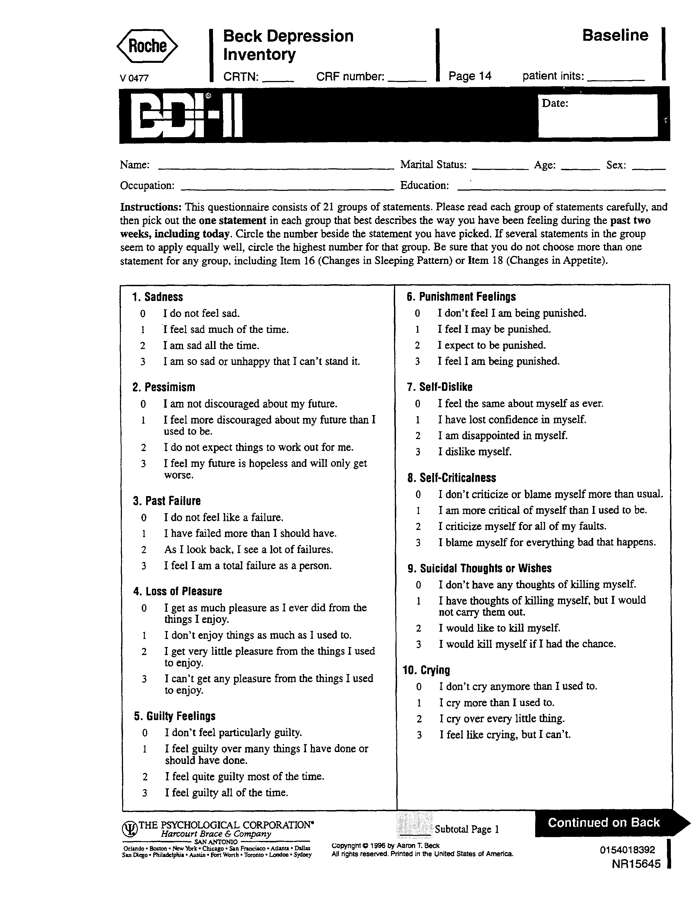

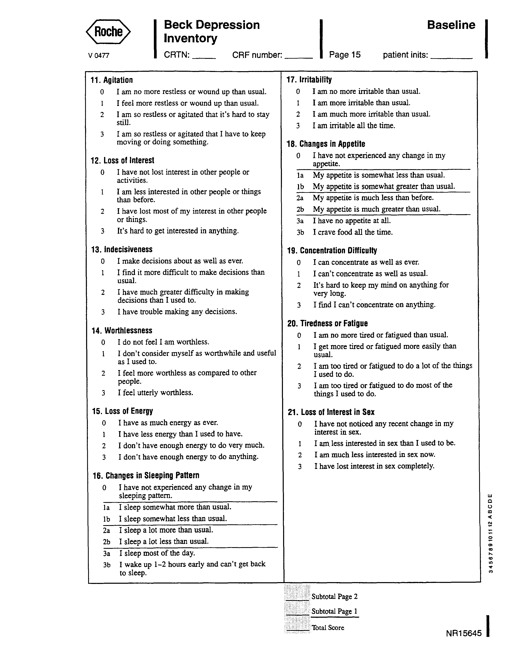

Theodicy is a several-centuries-old term that essentially refers to attempts to answer the following philosophical question: if God exists, and if God is good and loving, how can God permit evil and suffering?

